MVI FUNCTIONALITY

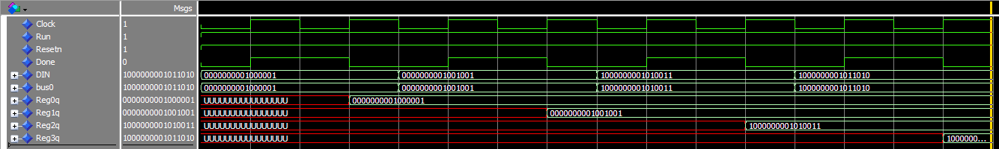

SET R0 to 01 000 001

SET R1 to 01 001 001

SET R2 to 01 010 011

SET R3 to 01 011 010

MV FUNCTIONALITY

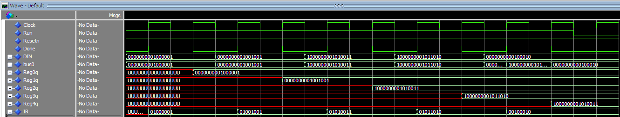

Move R2 to R4 [ We can see R4 gets the values from R2 ] disabled run and extended clock for viewing

ADD FUNCTIONALITY

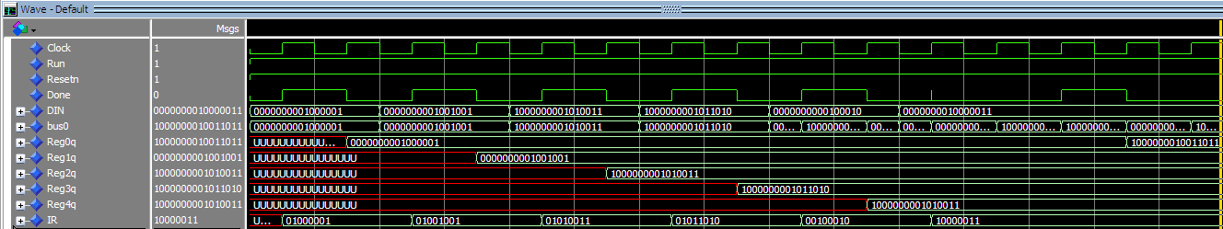



SUBTRACTION FUNCTIONALITY

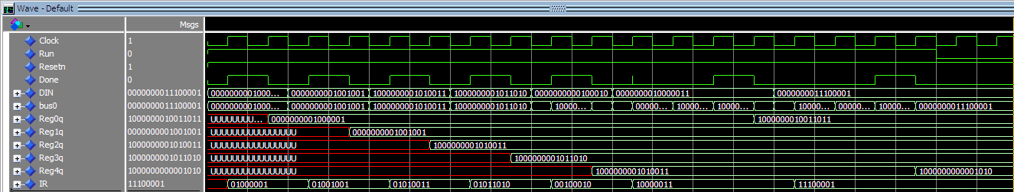

R4 – R1 🡪 R4



RUN & RESETN LOW

